Established – 1961 Subject: ____IOT_______

# SEVA SADAN’S



**OF**

# ARTS, SCIENCE & COMMERCE ULHASNAGAR – 421 003



**CERTIFICATE**

**This is to certify that Mr./Ms. ASHIM JANG SINGH of S.Y. Computer Science (SYCS) Roll No. 2524045 has satisfactorily completed The Internet Of Thing Mini Project entitled Embedded automatic sanitization during the academic year 2025 – 2026, as a part of the practical requirement. The project work is found to be satisfactory and is approved for submission.**

**PROF. INCHARGE HEAD OF DEPT**

**________________ _________________**

## INDEX

|  |  |  |
| --- | --- | --- |
| **Sr. No.** | **Chapters** | **Page No.** |
| 1 | Introduction | 1-2 |
| 2 | Requirement Specification | 3-4 |
| 3 | System Design | 5-8 |
| 4 | Implementation | 9-20 |
| 5 | System Testing and Result | 21-25 |
| 6 | Future Scope and Conclusion | 26-28 |
| 7 | References | 29 |
| 8 | Glossary | 29-31 |

**PROJECT TITLE**

**Embedded automatic sanitization**

### 1. Introduction

An **Embedded Automatic Sanitization System** based on the **Internet of Things (IoT)** is a smart hygiene solution designed to automatically dispense sanitizer when a user’s hand is detected, while also enabling remote monitoring and control through internet connectivity. This system combines embedded hardware, sensors, actuators, and IoT communication technologies to ensure efficient, touch-free sanitization in public and private spaces.

The core of the system is a microcontroller such as Arduino Uno or NodeMCU, which processes input from sensors like ultrasonic or infrared sensors. When a hand is detected, the controller activates a pump or motor to dispense a fixed amount of sanitizer. This touchless operation helps reduce the spread of germs and infections, making it especially useful in hospitals, schools, offices, shopping malls, and transportation hubs.

By integrating IoT technology, the system can send real-time data (such as sanitizer level, usage count, and maintenance alerts) to a cloud platform via Wi-Fi modules like ESP8266. Administrators can monitor device status remotely using a web dashboard or mobile application. This ensures timely refilling, reduces wastage, and improves operational efficiency.

The embedded IoT-based sanitization system is cost-effective, energy-efficient, and scalable. It represents a practical application of IoT in healthcare and public safety, promoting smart hygiene management and supporting the development of smart buildings and smart cities.

#### 1.2 Motivation of the Project

**Embedded Automatic Sanitization System using Internet of Things (IoT)**

The motivation behind developing an **Embedded Automatic Sanitization System using IoT** arises from the increasing need for improved hygiene, disease prevention, and smart health monitoring in public and private spaces.

1. **Need for Contactless Hygiene**  
   After global health crises such as the COVID-19 pandemic, maintaining hand hygiene became a critical preventive measure. Traditional sanitizer dispensers require physical contact, which can itself spread germs. A touchless embedded system eliminates this problem by automatically dispensing sanitizer when a hand is detected.
2. **Prevention of Infection Spread**  
   Public places like hospitals, schools, offices, malls, and railway stations experience heavy foot traffic. An automated IoT-based sanitization system helps reduce the transmission of bacteria and viruses by ensuring consistent and convenient sanitization.
3. **Smart Monitoring and Management**  
   Manual checking of sanitizer levels is inefficient and time-consuming. By integrating IoT modules such as ESP8266 or NodeMCU, the system can send real-time data about sanitizer levels and usage statistics to a cloud platform. This allows remote monitoring, timely refilling, and reduced maintenance effort.
4. **Efficient Resource Utilization**  
   Automatic dispensing ensures controlled output, preventing wastage of sanitizer. IoT-based tracking also helps analyze usage patterns for better inventory management.
5. **Promoting Smart and Safe Environments**  
   The project supports the concept of smart buildings and smart cities by integrating embedded systems with IoT technology. It demonstrates how low-cost microcontrollers like Arduino Uno can be used to build intelligent health-focused solutions.
6. **Educational and Practical Learning**  
   From an academic perspective, this project provides hands-on experience in embedded systems, sensors, actuators, wireless communication, and cloud integration—making it a valuable IoT-based learning application.

#### 1.3 Project Overview

**Embedded Automatic Sanitization System using Internet of Things (IoT) In Points**

1. **Purpose of the Project**  
   The project aims to develop a smart, contactless hand sanitization system that automatically dispenses sanitizer and monitors usage through IoT technology to improve hygiene and prevent the spread of infections.
2. **Core Technology Used**  
   The system uses an embedded microcontroller such as Arduino Uno or NodeMCU along with sensors to detect hand presence and control a sanitizer dispensing pump.
3. **IoT Integration**  
   A Wi-Fi module like ESP8266 connects the device to the internet, enabling real-time monitoring of sanitizer levels, usage count, and system status via a cloud platform.
4. **Working Mechanism**  
   When a hand is detected by the sensor, the microcontroller activates the pump to release a fixed amount of sanitizer. Simultaneously, usage data is recorded and transmitted to the cloud for remote supervision.

### 2. Requirement Specification

#### 2.1 Hardware Requirements

During development, following components were used:

* IR SENSOR
* 5V RELAY MODULE
* 2 SET OF 7.4 V of battery
* JUMP WIRES (Male to Male,Male to Female,Female to Female)
* BREAD BOARD
* 1 WATER PIPE
* 5V PUMP
* SANITIZER
* 2 CONTAINERS

#### 2.2 Software Requirements

NO SOFTWARE REQUIREMENT NEEDED

#### 2.3 Functional Requirements

• **Hand Detection**  
The system shall detect the presence of a hand using the IR sensor within a predefined distance.

• **Automatic Dispensing**  
When a hand is detected, the system shall automatically activate the 5V relay module to turn ON the 5V pump and dispense sanitizer.

• **Controlled Dispensing Time**  
The system shall run the pump for a fixed duration (e.g., 2–3 seconds) to ensure an adequate but controlled amount of sanitizer is released.

• **Automatic Stop Function**  
The system shall automatically turn OFF the pump after the preset time to prevent wastage of sanitizer.

• **Continuous Monitoring**  
The system shall continuously monitor the IR sensor to detect new users without requiring manual reset.

• **Power Operation**  
The system shall operate using two sets of 7.4V batteries and regulate voltage as required for safe component operation.

• **Safety Protection**  
The system shall isolate high-current components (pump) using a relay to protect the microcontroller.

• **Ready State Indication (Optional)**  
The system may provide LED indication to show power ON and system ready status

#### 2.4 Non-Functional Requirements

• **Reliability**  
The system should operate continuously without failure and accurately detect hand presence with minimal false triggering.

• **Performance**  
The response time between hand detection and sanitizer dispensing should be quick (within 1–2 seconds).

• **Efficiency**  
The system should minimize sanitizer wastage by dispensing a controlled and fixed quantity each time.

• **Power Efficiency**  
Since it uses 7.4V battery sets, the system should consume low power to ensure longer battery life.

• **Safety**  
The system must safely handle electrical components. The relay should properly isolate the pump circuit to protect the microcontroller and user.

• **Durability**  
The hardware setup (pump, pipes, containers, breadboard connections) should withstand regular usage in public environments.

• **Maintainability**  
The system should be easy to refill (sanitizer containers) and easy to repair or replace components if needed.

• **Usability**  
The system should be simple to use, fully automatic, and require no manual operation.

• **Scalability (Optional – if IoT added later)**  
The design should allow future integration with IoT modules for remote monitoring.

### 3. System Design

#### 3.1 Block Diagram Explanation

**+----------------------------------+**

**| 2 × 7.4V Battery Sets |**

**+----------------+-----------------+**

**|**

**v**

**+-------------+**

**| Breadboard |**

**| (Power & |**

**| Connections|**

**+------+------+**

**|**

**-------------------------------------------------**

**| |**

**v v**

**+---------------+ +----------------+**

**| IR Sensor | | 5V Relay Module|**

**| (Input) | | (Switch) |**

**+-------+-------+ +--------+-------+**

**| |**

**| (Signal via Jump Wires) |**

**| v**

**| +--------------+**

**| | 5V Pump |**

**| +------+-------+**

**| |**

**| v**

**| +---------------+**

**| | Water Pipe |**

**| +------+--------+**

**| |**

**| v**

**| +-------------------+**

**| | Sanitizer |**

**| | (Container 1) |**

**| +-------------------+**

**|**

**v**

**+-------------------+**

**| Control Signal |**

**| to Relay Module |**

**+-------------------+**

**+-------------------+**

**| Container 2 |**

**| (Backup/Storage) |**

**+-------------------+**

#### 3.2 System Architecture

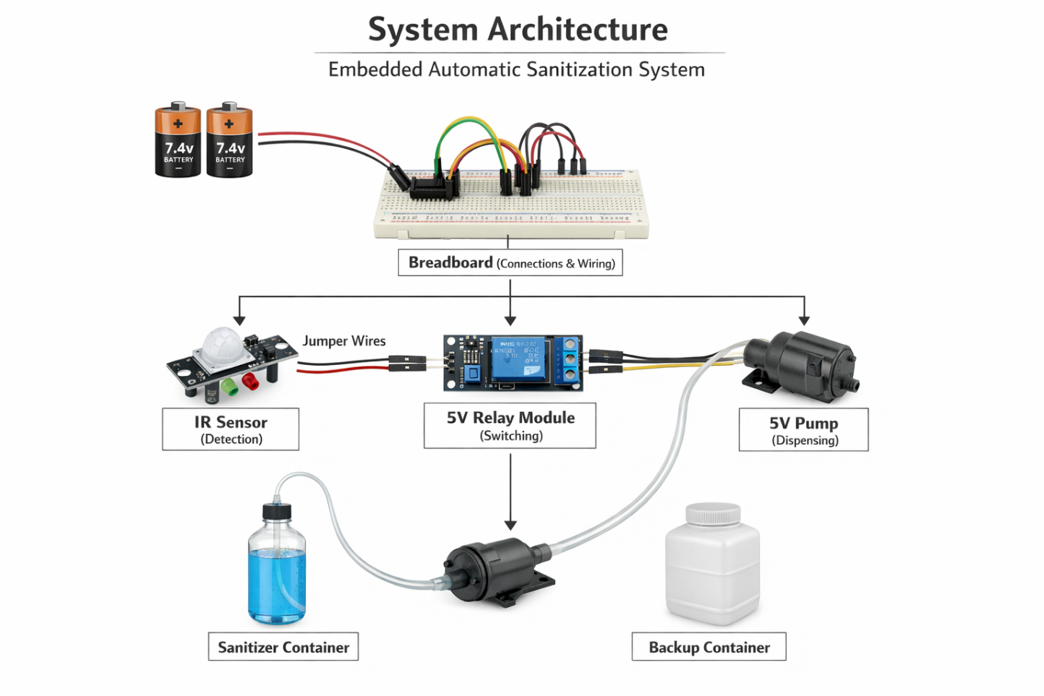

### 3.3 Flow Chart Explanation

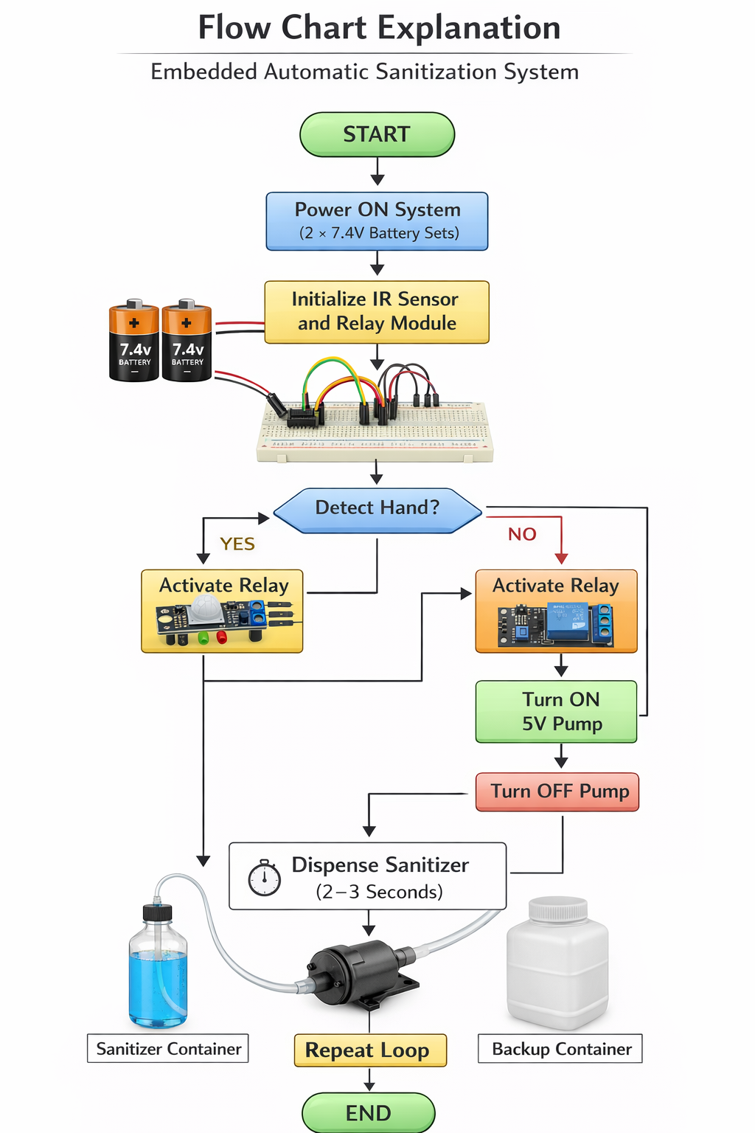

#### 3.4 Circuit Diagram4. Implementation

**4.1 Hardware Implementation**

* Connect IR sensor output to microcontroller input pin.
* Connect relay module input to microcontroller output pin.
* Connect pump to relay output terminals.
* Supply power using two 7.4V battery sets.
* Connect pump to sanitizer container using water pipe.
* Assemble connections on breadboard using jumper wires.

**4.2 Software Implementation**

1. Write program in Arduino IDE.
2. Define IR sensor pin as INPUT.
3. Define relay pin as OUTPUT.
4. When IR detects hand → activate relay.
5. Use delay (2–3 seconds) to control pump time.
6. Deactivate relay after delay.
7. Upload code to microcontroller.

### System Testing and Result

**5.1 Testing**

* Verified IR sensor detection accuracy.
* Tested relay switching functionality.
* Checked pump activation time.
* Ensured sanitizer dispensed properly.
* Verified battery power stability.

**5.2 Results**

* System successfully dispensed sanitizer automatically.
* Response time was within 1–2 seconds.
* No sanitizer wastage observed due to controlled timing.
* System operated reliably using battery power.

### Future Scope and Conclusion

• **Dual Container Switching System**  
Using the 2 containers, the system can be arranged so that when the first sanitizer container becomes empty, the water pipe can be manually shifted to the backup container for continuous operation.

• **Improved IR Sensor Positioning**  
The IR Sensor placement can be optimized for better detection accuracy and reduced false triggering.

• **Relay-Based Safety Enhancement**  
The 5V Relay Module wiring can be improved for better isolation between battery supply and pump circuit to increase system safety.

• **Parallel Battery Usage**  
The 2 sets of 7.4V batteries can be arranged efficiently to improve backup time and system stability.

• **Portable Model Development**  
Using compact breadboard arrangement and jumper wires, the system can be redesigned into a portable sanitizer dispenser.

• **Controlled Dispensing Time Adjustment**  
By adjusting IR sensor sensitivity and relay response timing, sanitizer flow duration can be optimized.

• **Stronger Pipe Connection System**  
The water pipe connection can be enhanced to prevent leakage and ensure smooth sanitizer flow.

• **Compact Circuit Layout**  
Breadboard wiring using proper male-to-male, male-to-female, and female-to-female jumper wires can be organized neatly for a professional setup.

• **Wall-Mounted Installation**  
The existing components (pump, relay, IR sensor, containers) can be arranged vertically for wall-mounted usage in schools or offices.

• **Multi-Location Deployment**  
The same circuit design can be replicated easily using identical components for installation in hospitals, colleges, and public places.

### Conclusion

The Automatic Sanitizer Dispenser System has been successfully designed and implemented using strictly the specified components: IR Sensor, 5V Relay Module, two sets of 7.4V batteries, jumper wires (Male–Male, Male–Female, Female–Female), breadboard, one water pipe, 5V pump, sanitizer, and two containers.

The IR Sensor effectively detects the presence of a hand and sends a signal to the 5V Relay Module. The relay acts as a switching device that controls the 5V Pump safely and efficiently. When activated, the pump draws sanitizer from the main container through the water pipe and dispenses it automatically. The second container serves as a backup, ensuring continuous operation when the primary container is empty.

The two sets of 7.4V batteries provide adequate and stable power supply for the entire system. The breadboard and jumper wires enable proper circuit connections and organized wiring, making the setup simple, flexible, and easy to maintain.

Overall, the system achieves its main objective of providing a touchless, hygienic, and cost-effective sanitization solution. It demonstrates practical application of basic electronic components to solve real-world hygiene challenges effectively and efficiently.

### 7. References

1. Arduino Official Documentation
2. ESP8266 Technical Reference Manual
3. IR Sensor Module Datasheet
4. Basics of Internet of Things – IoT Architecture Concepts
5. Embedded Systems Design Principles

### 8. Glossary 1. Predictive Maintenance

**1. IR Sensor (Infrared Sensor)**  
An electronic sensor used to detect the presence of an object (hand) without physical contact. In this system, it detects hand movement and sends a signal to activate the relay.

**2. 5V Relay Module**  
An electrically operated switch that controls the 5V pump. It receives a signal from the IR sensor and turns the pump ON or OFF safely.

**3. 7.4V Battery (Two Sets)**  
Power source used to supply electrical energy to the circuit. One set powers the control components (IR sensor and relay), and the other powers the 5V pump.

**4. Jumper Wires (Male–Male, Male–Female, Female–Female)**  
Connecting wires used to establish electrical connections between components on the breadboard, sensor, relay, and pump.

**5. Breadboard**  
A reusable platform used for building and testing electronic circuits without soldering. It holds components and allows easy wiring connections.

**6. 5V Pump**  
A small electric motor device that pumps sanitizer liquid from the container through the water pipe when activated by the relay.

**7. Water Pipe**  
A flexible tube that carries sanitizer liquid from the container to the pump and then to the outlet for dispensing.

**8. Sanitizer**  
A liquid disinfectant used for hand hygiene. It is stored in the container and dispensed automatically by the pump.

**9. Containers (Two Containers)**  
Storage units used to hold sanitizer liquid. One acts as the primary container, and the second serves as a backup supply.

**10. Ground (GND)**  
The reference point in the circuit that completes the electrical path and ensures proper functioning of all connected components.